**ITRI626 / ITRW878 – Klastoets 1 / Class test 1 – 7 Augustus / August 2018**

**Afdeling A (Blokkiesraaisel) / Section A (Crossword Puzzle)**

**Across**

**2** In propositional logic; a model simply fixes the ? value for every proposition symbol. (5)

**3** Complex ? are constructed from simpler sentences; using parentheses and logical connectives. (9)

**5** Our first algorithm for inference is a model-checking approach that is a direct implementation of the definition of entailment: enumerate the models; and check that alpha is true in every model in which ? is true. (2)

**Down**

**1** The ? sentences consist of a single proposition symbol. (6)

**3** The ? of propositional logic defines the allowable sentences. (6)

**4** A truth ? specifies the truth value of a complex sentence for each possible assignment of truth values to its components. (5)

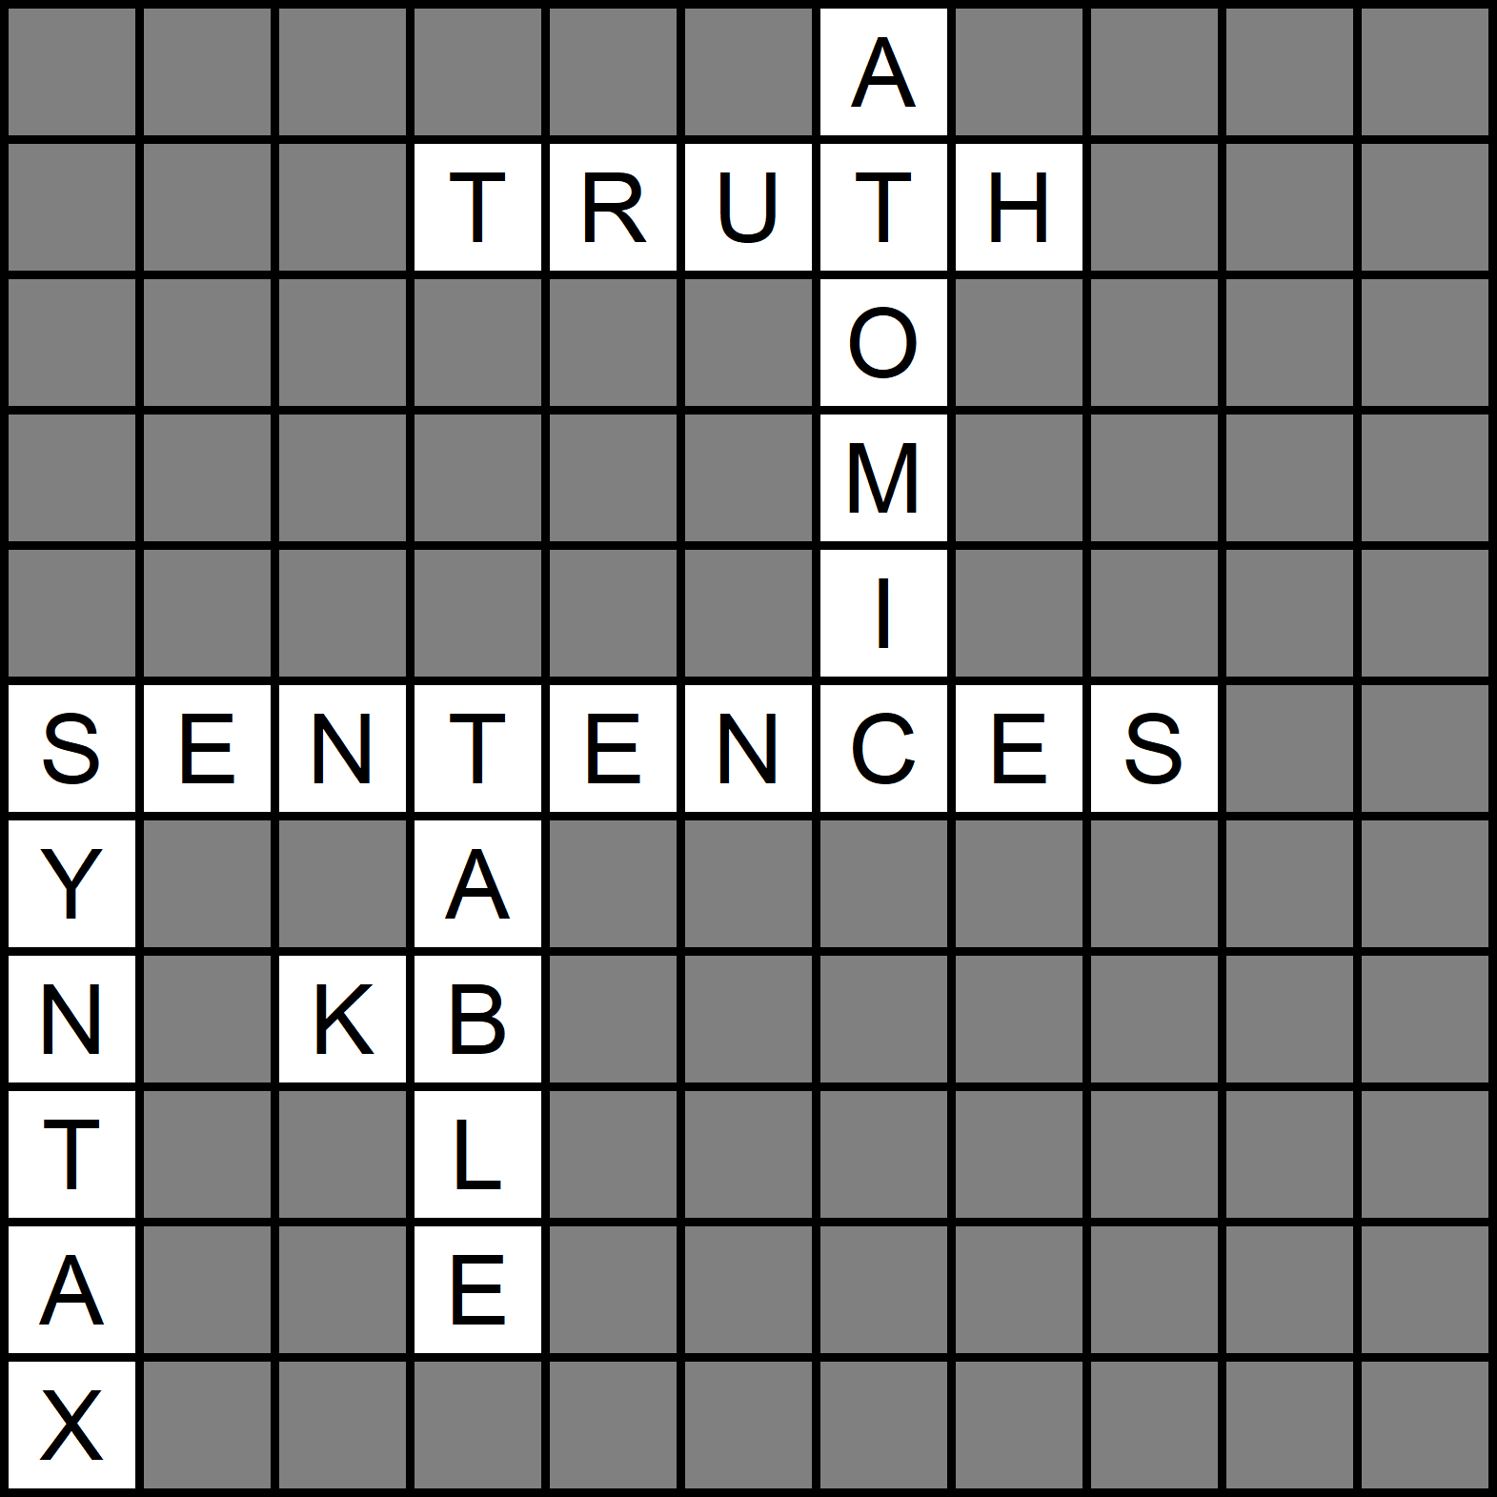

1. Which of the following propositional logic sentences is valid?

1. (P ⋁ Q) ⇒ Q
2. P ⋁ (Q ⇒ P)
3. **P ⋁ (P ⇒ Q)**
4. Both (B) and (C)

|  |  |  |  |  |  |  |  |
| --- | --- | --- | --- | --- | --- | --- | --- |
|  |  |  | Option A |  | Option B |  | **Option C** |
| P | Q | (P ⋁ Q) | (P ⋁ Q) ⇒ Q | (Q ⇒ P) | P ⋁ (Q ⇒ P) | (P ⇒ Q) | **P ⋁ (P ⇒ Q)** |
| T | T | T | T | T | T | T | **T** |
| T | F | T | F | T | T | F | **T** |
| F | T | T | T | F | F | T | **T** |
| F | F | F | T | T | T | T | **T** |

2. Which of the following is/are valid?

1. A ⋁ B ⇒ B ⋀ C
2. **A ⋀ B ⇒ B ⋁ C**
3. A ⋁ B ⇒ (B ⇒ C)
4. None of these

|  |  |  |  |  |  |  |  |  |  |  |
| --- | --- | --- | --- | --- | --- | --- | --- | --- | --- | --- |
|  |  |  |  |  | Option A |  |  | **Option B** |  | Option C |
| A | B | C | A ⋁ B | B ⋀ C | A ⋁ B ⇒ B ⋀ C | A ⋀ B | B ⋁ C | **A ⋀ B ⇒ B ⋁ C** | B ⇒ C | A ⋁ B ⇒ (B ⇒ C) |
| T | T | T | T | T | T | T | T | **T** | T | T |
| T | T | F | T | F | F | T | T | **T** | F | F |
| T | F | T | T | F | F | F | T | **T** | T | T |
| T | F | F | T | F | F | F | F | **T** | T | T |
| F | T | T | T | T | T | F | T | **T** | T | T |
| F | T | F | T | F | F | F | T | **T** | F | F |
| F | F | T | F | F | T | F | T | **T** | T | T |
| F | F | F | F | F | T | F | F | **T** | T | T |

3. P ⇒ (Q ⇒ R) is equivalent to

1. **(P ⋀ Q) ⇒ R**
2. (P ⋁ Q) ⇒ R
3. (P ⋁ Q) ⇒ ¬R
4. None of these

|  |  |  |  |  |  |  |  |  |  |  |
| --- | --- | --- | --- | --- | --- | --- | --- | --- | --- | --- |
|  |  |  |  |  |  | **Option A** |  | Option B |  | Option C |
| P | Q | R | (Q ⇒ R) | P ⇒ (Q ⇒ R) | P ⋀ Q | **(P ⋀ Q) ⇒ R** | P ⋁ Q | (P ⋁ Q) ⇒ R | ¬R | (P ⋁ Q) ⇒ ¬R |
| T | T | T | T | T | T | **T** | T | T | F | F |
| T | T | F | F | F | T | **F** | T | F | T | T |
| T | F | T | T | T | F | **T** | T | T | F | F |
| T | F | F | T | T | F | **T** | T | F | T | T |
| F | T | T | T | T | F | **T** | T | T | F | F |
| F | T | F | F | T | F | **T** | T | F | T | T |
| F | F | T | T | T | F | **T** | F | T | F | F |
| F | F | F | T | T | F | **T** | F | T | T | T |

4. ~~(P ⋁ Q) ⋀ (P ⇒ R) ⋀ (Q ⇒ S) is equivalent to~~

1. S ⋀ R
2. S ⇒ R
3. **S ⋁ R**
4. All of above

|  |  |  |  |  |  |  |  |  |  |  |
| --- | --- | --- | --- | --- | --- | --- | --- | --- | --- | --- |
| P | Q | R | S | P ⋁ Q | P ⇒ R | Q ⇒ S | (P ⋁ Q) ⋀ (P ⇒ R) ⋀ (Q ⇒ S) | S ⋀ R | S ⇒ R | S ⋁ R |
| T | T | T | T | T | T | T | T | T | T | T |
| T | T | T | F | T | T | F | F | F | T | T |
| T | T | F | T | T | F | T | F | F | F | T |
| T | T | F | F | T | F | F | F | F | T | F |
| T | F | T | T | T | T | T | T | T | T | T |
| T | F | T | F | T | T | T | T | F | T | T |
| T | F | F | T | T | F | T | F | F | F | T |
| T | F | F | F | T | F | T | F | F | T | F |
| F | T | T | T | T | T | T | T | T | T | T |
| F | T | T | F | T | T | F | F | F | T | T |
| F | T | F | T | T | T | T | T | F | F | T |
| F | T | F | F | T | T | F | F | F | T | F |
| F | F | T | T | F | T | T | F | T | T | T |
| F | F | T | F | F | T | T | F | F | T | T |
| F | F | F | T | F | T | T | F | F | F | T |
| F | F | F | F | F | T | T | F | F | T | F |

5. ~~(P ⋁ Q) ⋀ (P ⇒ R) ⋀ (Q ⇒ R) is equivalent to~~

1. P
2. Q
3. **R**
4. True

|  |  |  |  |  |  |  |
| --- | --- | --- | --- | --- | --- | --- |
| P | Q | R | (P ⋁ Q) | (P ⇒ R) | (Q ⇒ R) | (P ⋁ Q) ⋀ (P ⇒ R) ⋀ (Q ⇒ R) |
| T | T | T | T | T | T | T |
| T | T | F | T | F | F | F |
| T | F | T | T | T | T | T |
| T | F | F | T | F | T | F |
| F | T | T | T | T | T | T |
| F | T | F | T | T | F | F |
| F | F | T | F | T | T | F |
| F | F | F | F | T | T | F |

6. Which of the following is equivalent to P ⇒ Q?

1. ¬P ⇒ Q
2. **¬P ⋁ Q**
3. ¬P ⋁ ¬Q
4. **P ⇒ Q**

|  |  |  |  |  |  |  |  |
| --- | --- | --- | --- | --- | --- | --- | --- |
| P | Q | **P ⇒ Q** | ¬P | ¬P ⇒ Q | **¬P ⋁ Q** | ¬Q | ¬P ⋁ ¬Q |
| T | T | **T** | F | T | **T** | F | F |
| T | F | **F** | F | T | **F** | T | T |
| F | T | **T** | T | T | **T** | F | T |
| F | F | **T** | T | F | **T** | T | T |

7. Which of the following are well formed propositional formulas?

1. ∨PQ
2. **(¬(P ⇒ (Q ∧ P)))**
3. (¬(P ⇒ (Q = P)))
4. (¬(◊(Q ∨ P)))

8. Is (¬P ∨ Q) ∧ (Q ⇒ ¬R ∧ ¬P) ∧ (P ∨ R) satisfiable?

1. No
2. **Yes**

|  |  |  |  |  |  |  |  |  |  |
| --- | --- | --- | --- | --- | --- | --- | --- | --- | --- |
| P | Q | R | ¬P | ¬R | ¬P ⋁ Q | ¬R ⋀ ¬P | Q ⇒ ¬R ∧ ¬P | P ⋁ R | (¬P ∨ Q) ∧ (Q ⇒ ¬R ∧ ¬P) ∧ (P ∨ R) |
| T | T | T | F | F | T | F | F | T | F |
| T | T | F | F | T | T | F | F | T | F |
| T | F | T | F | F | F | F | T | T | F |
| T | F | F | F | T | F | F | T | T | F |
| F | T | T | T | F | T | F | F | T | F |
| F | T | F | T | T | T | T | T | F | F |
| F | F | T | T | F | T | F | T | T | T |
| F | F | F | T | T | T | T | T | F | F |

9. Determine whether the formula P ∧ ¬Q ⇒ P ∧ Q is a logical consequence of the formula ¬P

1. No
2. **Yes**

|  |  |  |  |  |  |  |  |
| --- | --- | --- | --- | --- | --- | --- | --- |
| P | Q | ¬Q | P ⋀ ¬Q | P ⋀ Q | P ∧ ¬Q ⇒ P ∧ Q | ¬P | (¬P) ⇒ (P ∧ ¬Q ⇒ P ∧ Q) |
| T | T | F | F | T | T | F | T |
| T | F | T | T | F | F | F | T |
| F | T | F | F | F | T | T | T |
| F | F | T | F | F | T | T | T |

10. Verify whether the following formula is valid, satisfiable or unsatisfiable: (P ⇒ Q) ⇒ (P ⇒ ¬Q)

1. Valid
2. **Satisfiable**
3. Unsatisfiable

|  |  |  |  |  |  |
| --- | --- | --- | --- | --- | --- |
| P | Q | ¬Q | (P ⇒ Q) | (P ⇒ ¬Q) | (P ⇒ Q) ⇒ (P ⇒ ¬Q) |
| T | T | F | T | F | F |
| T | F | T | F | T | T |
| F | T | F | T | T | T |
| F | F | T | T | T | T |

11. Verify whether the following formula is valid, satisfiable or unsatisfiable: (P ∨ Q ⇒ R) ∨ P ∨ Q

1. **Valid**
2. Satisfiable
3. Unsatisfiable

|  |  |  |  |  |  |  |
| --- | --- | --- | --- | --- | --- | --- |
| P | Q | R | P ⋁ Q | (P ∨ Q ⇒ R) | (P ∨ Q ⇒ R) ⋁ P | (P ∨ Q ⇒ R) ∨ P ∨ Q |
| T | T | T | T | T | T | T |
| T | T | F | T | F | T | T |
| T | F | T | T | T | T | T |
| T | F | F | T | F | T | T |
| F | T | T | T | T | T | T |
| F | T | F | T | F | F | T |
| F | F | T | F | T | T | T |
| F | F | F | F | T | T | T |